**ST. JANAN LUWUM SECONDARY SCHOOL KABALAGALA**

**S.2 END OF TERM ONE GEOGRAPHY EXAMINATION.**

**TIME: 2HOURS.**

**INSTRUCTIONS**

**Attempt all items.**

**Item1**

The natural resources in our areas are a basis for our survival. The food we eat, water we drink, houses we construct and the medicine we use. Unfortunately, in the process of utilizing these resources accidents have occurred on lakes, mines and forests scaring many from proper exploitation. Of recent local leaders in Kajjansi Town council had to close a quarry for unidentified period due to rampant accidents that had claimed many live. Many local people demonstrated opposing the indefinite closure of the source of their livelihood. The Wakiso District council got concerned over that issue. They organized a meeting over to be held at the quarry site.

**Support material**

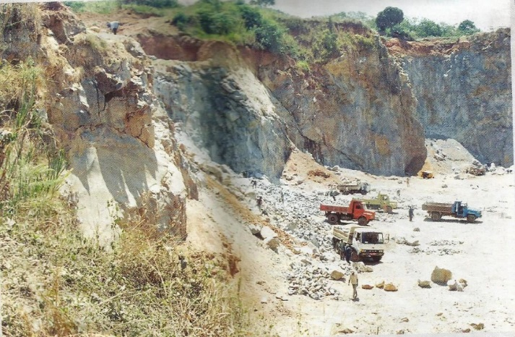

**Fig.1**

**Task.** You were appointed as one of the people who will present in the meeting.

Prepare a written document which you will read to the gathering pointing out the following;

a) Importance of re-opening the quarry, (5scores)

b) Safety measures which can be applied to keep mining operations and people’s lives. (5scores)

**Item 2**

The 3rd november 2013 entered into the world books of records as residents of a small Ugandan town Pakwach witnessed a rare geographical phenomenon. It was a Sunday and it lasted for only few minutes. The town went on the international spotlight. Residents went to bed durring day time and woke up to hordes/large groups of people local and international who had come to witness this rare occurance once in their life time. Another one of the kind is projected to happen again in 2172! Many tour operators made fortunes. However, many people had mixed reactions, some ignorantly argued that the moon was fighting the sun, that is why the sun was shortly defeated and disappeared causing darkness durring day time.

**Support photo: The sun dissapearing durring day time.**

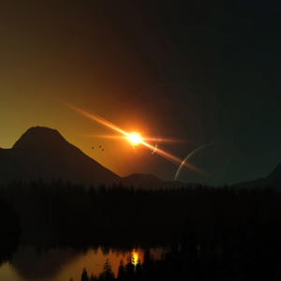

Fig.2

**Task**. As a geographer,explain with clear illustrations what Uganda (Pakwach town) experienced on the 3rd November 2013. (10 scores)

**Item 3**

Students of S.t Janan Luwum secondary school go for study tour trips in different places each year to experience what they study practically for better lerning and mastering of concepts. In 2022, they visited the Uganda Meteorological Center at Entebbe. They saw many instruments and instruments which are used to measure the elements of weather.

**Support material**s.

A B

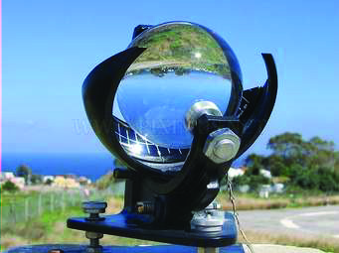 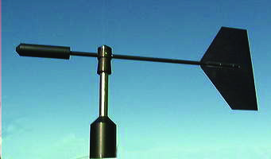

Fig.3

C

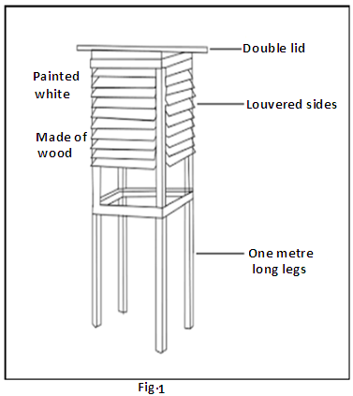

**Fig. 4**

**Tasks:**

1. Make a report and indicate the structure and instruments shown in the support materials above. Show the elements of weather measured by the instruments.
2. For structure **C,** Choose **two** of the features labelled in Fig.4. For each of the features you have chosen, explain why it has been designed in this way.

***END***